Room C
CQ1 Trauma MVC Pancreatic Injury.
Stem: In the trauma bay, A 35-Year-old female, involved in a head on MVC. ATLS protocols are followed. You do primary and secondary surveys. IV access ensured, she is talking to you and is complaining of pain primarily in her chest and abdomen.
Vitals: HR of 130, BP 150/90, RR 18 and sating 99% on room air.
She is noted to have a seatbelt sign and. Her chest wall is mildly tender, her abdomen is peritonitic with severe epigastric tenderness.
Medical and Surgical history are unremarkable.
FAST / CXR are negative.
Discussion
How are you going to manage this patient?
- ATLS
- Trauma panel (Labs are significant for WBC 16.0, Hgb 12.2, CMP is normal, and amylase is 300, lactate 1.0.
- CT scan shows a small amount of free fluid around the left upper quadrant and lesser sac, as well as a Grade 4 splenic laceration.
What is your differential diagnosis?
- Known splenic injury.
- Pancreatic Injury
- Perforated viscus (small bowel or stomach)

After CT scan, her BP trends down to 80/40, HR 140.
- Transfuse blood products (start with 2 units PRBCs)
- Ex.lap
  - Open / Explore
  - Pack 4 quadrants (Blood Pressure responded to transfusion)
  - Splenectomy
  - Explore
Splenectomy was uncomplicated, hemostasis achieved, patient is hemodynamically stable.
You notice mild contusion of the pancreatic body, you can’t see obvious duct injury? What would you do?
Place Darin
You place a drain and conclude your operation, patient is closed, no packs left. Patient is clinically stable on POD 1 , on POD 2 you notice the drain is putting > 350 cc per day , output looks serosang. Your junior resident is asking you if they can obtain labs from the drain output, would you like to order specific labs?
Amylase from drain: > 2 times upper limit of normal
Next day drain is with higher output , what would you like to do?!
- MRCP with secretin stimulation for evaluation of main pancreatic duct (ERCP is an acceptable alternative , but risk of worsening pancreatitis in trauma patient): MRCP negative
- Consider octreotide.
- Repeat CT in 4-6 weeks?
What If persistent drainage , now a fistula? ERCP / Stent
What if when obtained MRCP earlier, it showed main pancreatic duct disruption?! ERCP/ Stent
ERCP attempted, Due to the patient’s anatomy, multiple attempts at pancreatic ductal cannulation were unsuccessful and the procedure was aborted. The patient continues to have high output of the LUQ drain despite being on octreotide How would you manage?

Ex lap for distal pancreatectomy.
- Attachments of spleen will already have been mobilized thus mobilize splenic flexure more if improved visualization needed.
- Open entirety of gastrocolic ligament.
- Mobilize tail of pancreas to confluence of SMV/Splenic vein and transect pancreas.
- Sharp division or division with energy device with oversewing of duct and gland. +/- oversewing .
- Can cover with omentum.

Pitfalls:
- Differential diagnosis does not include pancreatic injury or perforated viscus.
- When to transfuse.
- When to Ex.lap for splenectomy.
- Resident not exploring lesser sac to evaluate for pancreatic injury
- Resident Not leaving a drain in the setting of pancreatic contusion.
- Not checking fluid and serum amylase level with high drain output and known pancreatic injury.
- Risk of pancreatitis with ERCp , start with MRCP.
- Recognize the need for distal pancreatectomy and intervention prior to obliterative peritonitis.
References:
- https://www.ncbi.nlm.nih.gov/books/NBK459365/#:~:text=ERCP%2Dguided%20stent%20placement%20or,injury%20in%20blunt%20abdominal%20trauma.

CQ2 Low Rectal Cancer.
Stem: : 80 y male presenting with pain with defecation, blood on the toilet paper when he wipes, and weight loss over the last three months. Past medical history of CAD with prior 3v CABG 10 years ago, HTN. Prior surgeries include CABG, lap chole and open right inguinal hernia repair. He is physically active and walks 2 miles a day with his dog without chest pain or sob. Physical exam is normal except for external hemorrhoids without stigmata of bleeding and a firm mass 4cm in size about 3cm from the anal verge, extending 50% around the circumference. Mobile on palpation. How would you proceed?

Discussion

Any other information you would like to know? Any Additional Workup or Studies:
- Labs? CMP no abnormalities, CBC with Hgb 10.2
- Tumor markers? CEA 15
- Last colonoscopy? More than 10 years ago, he was told he has hemorrhoids.
Proceed with full colonoscopy?! --- Who will do it?-- I will do it - describe it
On colonoscopy you find, no evidence of synchronous lesions, you biopsy the mass and it reveals adenocarcinoma (Resident should state they will do the colonoscopy themselves, able to describe it, resident should obtain and wait for biopsy results recognizing that histopathology of the tumor will dictate management)
What would you like to do now? Staging Work up
1. CT scan chest/abdomen/pelvis: No metastases
2. MRI pelvis (superior to endorectal US): Shows invasion of the tumor into the muscularis propria (T2 lesion) with two mildly enlarged lymph nodes in the perirectal tissues.

How would you manage this patient?
- Multidisciplinary tumor board discussion.
- Neoadjuvant chemotherapy/radiation. Do all rectal cancer patients get neoadjuvant chemoradiotherapy? T3 and higher / Any T with N+ve on clinical workup)
What is the regimen?!
- 5 weeks of radiation (5,040 Gy) + continuous 5FU or capecitabine therapy

Patients conclude their neoadjuvant chemoradiotherapy, now what?
- Repeat staging scans (CT chest/abd/pelvis and MRI pelvis)
- Surgery 6-8 / 8-10/ 10-12 weeks after Chemoradiation, all acceptable

What surgery? patient tells you with the chemoradiotherapy he suffered incontinence, and he doesn’t that to continue for the rest of his life
APR with a total mesorectal excision with negative colon radial margin (CRM)

Describe it : After bowel prep with mechanical , antibiotic prophylaxis, mark & pre-op for ostomy site

a. Abdominal portion: (Open / lap / Or Robotic … Lateral to medial or medial to lateral dissection)
i. Start with patient in dorsal lithotomy, lower midline celiotomy, examine for mets, mobilize the sigmoid colon along white line of Toldt or via medial to lateral approach score the peritoneum along the right side, identify the inferior mesenteric artery , , identify left ureter, and perform high ligation.
ii. Enter the mesorectal plane by scoring the peritoneum, use sharp dissection to circumferentially dissect sharply to obtain total mesorectal excision, carry down to the pelvic floor.

b. Perineal portion:
i. Elliptical incision 2-3 cm from anal verge
ii. Place lone star retractor ii. Incision to ischiorectal fossa
iii. Carry dissection posteriorly, palpate the coccyx, stay anterior to this and divide the anococcygeal ligament.
iv. Enter the peritoneal cavity.
v. Resect the levator ani muscle laterally.
vi. Continue the dissection anteriorly along the rectum between the prostate and the rectum.
vii. Close the perineal wound in multiple layers, leave drain.

Scenario: What if the mass is palpated at 4cm from the anal verge and is
- 2cm in size
- Only 20% of the circumference affected.
- Mobile on exam
- Biopsy demonstrates adenocarcinoma, well differentiated with no lymphovascular or perineural invasion.
- Colonoscopy shows no other lesions
- MRI consistent with (T1 tumor) without suspicious lymphadenopathy
- CT C/A/P with no metastatic disease.
How would you manage?
Wide Local excision. - What’s your margin? 1 cm - How deep you go? Full thickness to the perirectal fat.

Scenario 2: In a different patient, what if the tumor is in the upper rectum, biopsy proven adenocarcinoma. MRI pelvis demonstrates T1 lesion at 15cm from the anal verge, no suspicious lymphadenopathy, above and without involvement of the peritoneal reflection. Your patient has excellent continence and bowel control at baseline. What surgery would you offer?

Low anterior resection, with tumor specific mesorectal excision.
What criteria allows you to offer local excision in low rectal cancers?
- T1 rectal cancers
- Within 8cm of the anal verge or below first rectal valve
- No high-risk features (no lymph vascular invasion
- Less than 3cm in diameter.
- 0% of the circumference of the bowel lumen)

CQ3 GIST Stomach

Stem: A 70yoF present to your office with complaints of 4 months of early satiety. He denies any nausea/emesis, constipation. He denies hematochezia or hematemesis. Last colonoscopy was 5 years ago, normal. He endorses a 10lb weight loss in the same amount of time

PMHx: hyperlipidemia, hypertension

PSHx: inguinal hernia repair 30 years ago

Meds: metoprolol, cholesterol med, baby aspirin

SocHx: social drinker; 20 pack year history smoker, quit 20 years ago

FH: Non-contributory

Vital Signs: BP 142/85 HR 75 99% on room air

PE: well appearing male although thin. Abdomen soft, nontender with palpable left upper abdominal mass. No associated lymphadenopathy

How would you work up this patient?

Work up:

CT abd/pelvis with IV/PO contrast – 7cm heterogenous mass associated with the gastric fundus without evidence of liver or peritoneal metastases or adenopathy

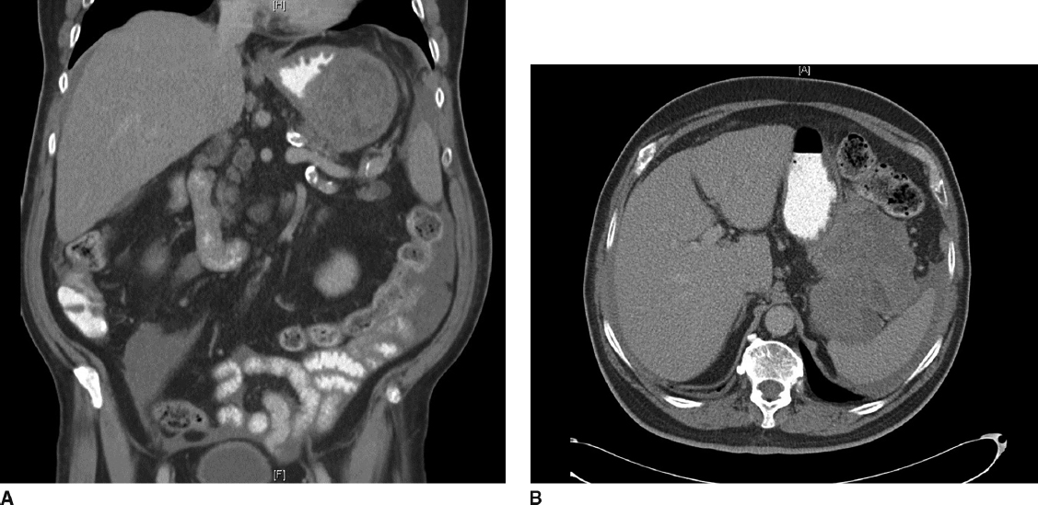

Diagnosis:

Gastrointestinal stromal tumor

What would you like to do next?

EGD

How would you perform that procedure?

Procedural sedation

Place in left lateral decubitus position

Insert scope into mouth under direct visualization

Pass the scope past the cricoarytenoid cartilage into the esophagus

Ensuring direct visualization, pass the scope through the esophagus with continuous insufflation in order to visualize the entire esophagus

Visualize the gastroesophageal junction and pass into the stomach

EGD demonstrates large submucosal mass without any ulceration.

If examinee asks for :
- biopsy: no pathologic abnormality
- EUS: large heterogenous mass contiguous with gastric wall without perigastric lymphadenopathy
- FNA: spindle cells, immunohistochemistry not performed. (FNA not necessary unless concerned for metastatic spread, unresectable or neoadjuvant therapy is planned)
- MRI or PET – not available

How would you treat this patient?

Resectable GIST. No neoadjuvant therapy is necessary

Describe operative approach:

Can perform laparoscopically or open.
- If laparoscopic need to describe position and port placement: lithotomy or supine position with 12mm port to the left of the umbilicus, 4 additional ports – right of umbilicus, right costal margin, left costal margin and liver retractor
- Open – supine position, upper midline celiotomy

Examine the abdomen for metastases

Resect the GIST with 1cm gross margin utilizing staple device, ensuring not to narrow the gastroesophageal junction.

Should use endoscopy or bougie to ensure against narrowing of stomach or GE junction. Should perform leak test

Ensure not to disrupt the pseudocapsule and cause spillage of tumor

Post operative care

Advance diet as tolerated

Pathology returns as below: Any other recommendations for this patient’s care?

7cm gastrointestinal stromal tumor with mitotic rate >50/HPF

Follow up:

Imatanib for at least 3 years

H&P as well as CT scan every 6months-1 year for at least 10 years

Pitfalls:

Performing total gastrectomy for GIST
performing lymphadenectomy without obvious evidence of involvement

Not placing patient on imatanib given pathology

